School Name Parkview Middle School | Contact Information  - Danielle Whitmire (7 Platinum) danielle.whitmire@ankenyschools.org Extension: 1228  - Laura Bray (7 Gold) laura.bray@ankenyschools.org, Extension: 1208  - Alex Loudon (7 Maroon) alex.loudon@ankenyschools.org Extension: 1238  School Phone: (515) 965-9640
Course Pre-Algebra

Grade Level Standards
- Math 07.01 Students will be able to add, subtract, multiply, and divide rational numbers
- Math 07.02 Students will be able to use properties of operations to create equivalent expressions, as well as write and solve equations in one variable.
- Math 07.03. Students will be able to analyze proportional relationships and use them to solve real world and mathematical problems
- Math 07.05 Students will be able to understand and apply slope
- Math 07.06.Students will be able to use and apply positive exponents and scientific notation, as well as evaluate roots

Student progress will be monitored and communicated on grade level standards:
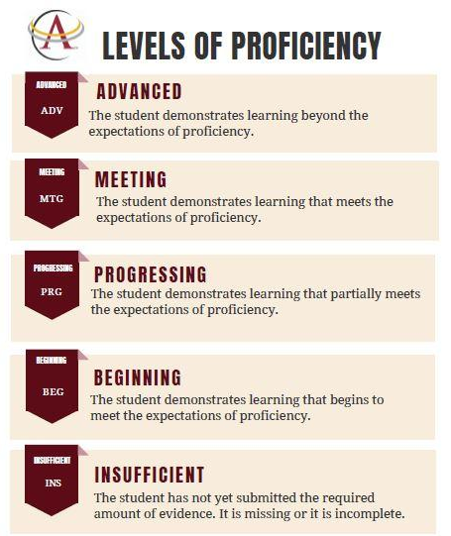 | - A Level of Proficiency will be assigned for each grade level standard.  - At each reporting period students will receive a beginning, progressing, meeting or advanced mark to indicate progress toward mastery of each standard.  - Teachers will show the connection between a student’s performance on evidence collected and a level of proficiency. This connection will be communicated throughout the learning progression in class for the purpose of providing student feedback.  - Infinite Campus will be utilized to communicate progress toward proficiency on grade level standards.  - While Infinite Campus will typically reflect current levels of proficiency, communication around student progress will be electronically updated (current to-date) at 9, 12, and 18 weeks each semester.
Multiple and Varied Opportunities to Demonstrate Proficiency
All students will have multiple and varied opportunities to demonstrate proficiency. Additional opportunities may include demonstrating proficiency on only the content/skills not mastered, spiraling of content/skills with subsequent standards, or utilizing an alternate type of evidence (e.g., oral vs. written response, student revision of work products based on descriptive feedback, etc.).
- Teachers determine appropriateness and authentic need for additional opportunities.
- Additional opportunities will be provided at the discretion of the teacher.
- Additional opportunities will be given within a reasonable time frame that the teacher determines and students will be communicated with in advance.

The Role of Homework
Homework is an opportunity for students to practice skills, apply knowledge, review and build on past learning, and extend learning. Homework is individualized and based on each student’s progress towards established standards. Through independent learning tasks (homework), students assume more responsibility for their learning and are given opportunities to apply what they have learned to new situations or experiences.

Work Habit Expectations
The work habits standards are for courses in grades 6-12 . These work habit standards will be reported throughout the semester and are as follows:

Work Habits Standards | Performance Levels for Work Habits Standards:
- Organization and Readiness  - Productivity and Accountability  - Collaboration Skills | MS = Meets Standard  PM = Partially Meets Standard  DM = Doesn’t Meet Standard  NE = No Evidence

Ways to Support Your Learner at Home
Inquire about what your child is learning in class.
What are you learning about in class?
What do you need to do to meet the standard?
How might you get to the next level of proficiency? (ie. progressing to meeting or meeting to advanced)
How would you rate your work habits in Pre-Algebra class? Why?
Check the Team Agenda with your child.
Team agendas communicate classroom activities, homework, and additional learning opportunities.
Encourage your child to ask questions.
Prompt your child to ask questions of their teachers in person or via email as the need arises.

District Office 306 SW School Street PO Box 189 Ankeny, IA 50021-0189
P: 515.965.9600 F: 515.965.4234 W: ankenyschools.org

Ankeny Community School District does not discriminate based on race, color, creed, religion, national origin, sex, gender identity, age, disability, marital status, sexual orientation, physical attributes, physical or mental ability or disability, ancestry, political party preference, military affiliation, socioeconomic status, or familial status. Inquiries or grievances may be directed to Ken Morris Jr., Equity Director, 306 SW School Street, P.O. Box 189, Ankeny, IA, 50021-0189, (515) 965-9600, kenneth.morris@ankenyschools.org; or the Iowa Civil Rights Commission, Grimes State Office Building, Des Moines, IA, 50319-0201, (515) 281-4121; or the U.S. Department of Education, Office for Civil Rights, 500 West Madison Street, Suite 1475, Chicago, IL 60661.

